**Assignment** 13.

1. Consider the multi-way search tree of Slide 5 in the Lecture 13 notes, is it a (2,4) tree? Justify your answer.

NO, it is not satisfy the condition all external nodes have the same depth.

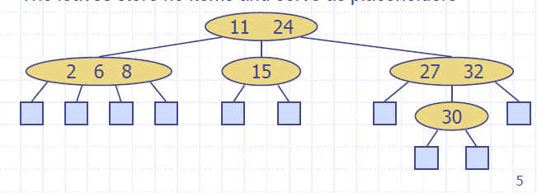

2. Consider the following sequence of keys:

(5, 16, 22, 45, 2, 10, 18, 30, 50, 12, 1, 25, 7)

Insert items with this set of keys, in the order given, into an empty (2,4)-tree.

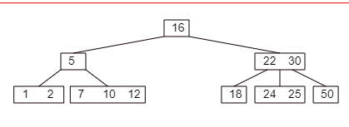

R-3.10 A certain Professor Amongus claims that a (2,4) tree storing a set of items will always have the same structure, regardless of the order in which the items are inserted. Show that Professor Amongus is wrong.

The reverse of #2

(7, 25, 1, 12, 50,3 0, 18, 10, 2, 45, 22, 16, 5)

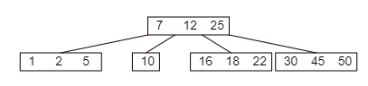

So as we can see from diagram the sequence and its’ reverse give different structure